**TEAM AGREEMENT GUIDELINES**

**For**

***Group 114***

***Version 0.1 (DRAFT)***

**Prepared by:**

***James Tuerlings 08351473***

***Ahmed Shoeb Talukder 09076336***

***Daniel Stevenson 09163255***

***Daniel Naughton 09158944***

***Thevidu Randula 09472274***

***Harry Whittaker 09478451***

**Prepared for:**

***Prakash Bhandari***

***27/07/16***

# Sign-off and Approvals

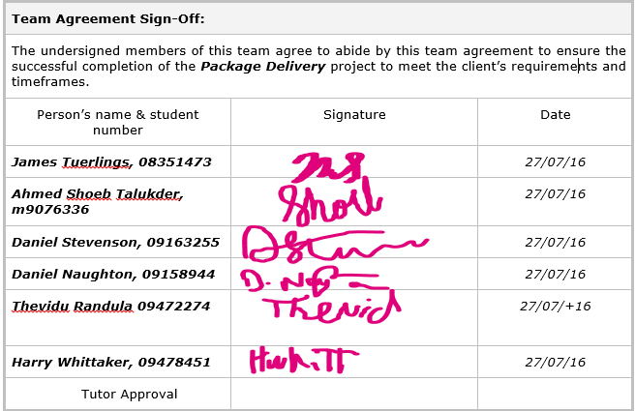

***Instructions: You may use this template to plan and discuss your team agreement by substituting and adding your own ideas and text wherever there are italics throughout the document.***

Table of Contents

Sign-off and Approvals ii

1 Introduction 1

2 Team Agreement 1

2.1 Team Principles and Processes 1

2.2 Non-Compliance 1

2.3 Dispute Resolution & Conflict Management 1

3. Conclusion 1

References 1

Appendix – Team Agreement Guidelines 1

Possible Topics for Agreement Principles 1

Communication and Operational Process Topics 1

Defining Major and Minor Non-Compliance 1

Penalties for Major and Minor Non-Compliance 1

# Introduction

The purpose of this document is to discuss and agree on the operating norms (principles and communication processes) for Group 114 who are a team of students in IFB299 Application Design and Development.

The aim of the team agreement is to describe the principles underpinning effective teamwork and how they will be applied by this team during the ***Package Delivery*** project. In this way the agreement provides a communication tool and contract between team members and their tutor regarding their obligations, responsibilities and activities to ensure successful processes, product, and outcome.

This document includes:

* High level principles contributing to an effective team;
* Agreed communication and operational processes to action the principles.
* Definitions of minor and major non-compliance and examples of instances that may constitute a breach of the agreement’s conditions.
* Dispute resolution and conflict management processes.

# Team Agreement

All team members must have participated in the formulation of this Team Agreement and are committed to abide by it.

## Team Principles and Processes

1. ***Maintaining respectful communication***
   1. *Respectful communication is an important tool for consistent productivity*
      1. *This will be done by avoiding abusive language, respecting each other’s opinions and using the appropriate channels*
2. ***Committing to a fair and equal workload***
   1. *It is important that all team members participate equally to ensure that no single person is forced to bear a majority of the work*
      1. *This will be enforced through Git Logs and reporting to our tutor if we feel that this principle has been violated*
3. ***Conflict management will be done in a professional and respectful manner***
   1. *This is to ensure that disagreements do not impact the productivity of the team or the quality of the project. Additionally this will ensure that team members do not feel uncomfortable during the project*
      1. *This will be done during team meetings, using level-headed and rational arguments. If a resolution cannot be reached, then a tutor or lecturer should be contacted*
4. ***Team members will help to assure the quality of each other’s workload in a constructive and non-derogatory way***
   1. *This is to ensure that work is completed to a high standard without degrading any individual who has submitted work that is deemed unsatisfactory*
      1. *This will be done by routinely perusing each other’s work on the online repository and submitting constructive criticism through the appropriate channels*
5. ***Deadlines should be used to enforce timely completion of work***
   1. *This is to ensure timely completion of work*
      1. *This will be done by implementing weekly deadlines that adhere to the Agile principles used within this unit*

***Minor non-compliance*** *involves a partial breach of the principles outlined in this document. An example of this would be a team member failing to meet a deadline by a few days or by criticising a team member’s work in a non-constructive but not overly offensive manner.*

*In contrast, a* ***Major non-compliance*** *involves a significant breach of principle in such a way that the project is significantly and irrevocably damaged as a result. An example of this would be an argument of a physically violent nature or a lack of communication for an extended period of time. Consistent failure to deliver content could also fall into this category.*

## Dispute Resolution & Conflict Management

***Minor or major non-compliance with this Agreement is likely to manifest as disputes or conflicts between team members.***

***State how your team has agreed to deal with or manage minor breaches of this Agreement****.*

*In response to a minor breach of policy, a simple discussion should take place between the offending party and another team member. If the issue escalates, more team members may be involved.*

***State how your team has agreed to deal with or manage major breaches of this Agreement****.*

*In response to a major breach of policy, a full team meeting should be arranged. Should this not suffice, a second meeting with a tutor or other relevant offical will be arranged.*

# 3. Conclusion

This document has articulated the high level and operational processes agreed to by Group 114***.*** This team agreement will apply for the duration of the **Package Delivery**. To meet the objectives of the project and demonstrate their abilities as IT professionals, team Group 114will implement the principles, processes and management activities described.

# References

***Provide any references you have used to construct this proposal.***

# Appendix – Team Agreement Guidelines

In order for your team to achieve its common goals, to coordinate activities and to enable group synergy, your team and its members must communicate regularly and abide by mutually acceptable and beneficial principles of behaviour.

In the ITB002 students form their own teams. Team members can then negotiate team principles and operational process and record these conditions in their Team Agreement. In developing the Team Agreement team members must also agree what constitutes a major breach of (non-compliance with) of agreed behaviours, the penalties for such breaches.

The notions of team agreements and team meetings were introduced in the week 1 lecture and you have been completing some online teamwork learning activities as part of your team process management.

Some possible topics for consideration in the Team Agreement are listed below. Your team should develop **principles** and **operational processes** and any other relevant items you think are necessary to establish the “rules” by which your team will operate. A template is available to help you identify content items and structure your agreement.

## Possible Topics for Agreement Principles

The guiding principles you develop might address the following issues:

* Your team goals (How you will define success. What level of achievement / grade does your team want for this project);
* How your team will reach consensus when decision-making;
* How the team will manage & resolve differences of opinion. (Will the team require all individuals to accept the team's view?);
* How you will get quiet team members or students who have English as a second language to actively contribute to team discussions;
* How team members will share knowledge and actively collaborate with other team members to ensure collaboration;
* How tasks will be allocated and how work will be completed (will you work according to the project plan, or use an event-driven informal process?);
* How your team will resolve or accept personal or professional differences;
* The process or channel will you use to escalate issues that the team cannot resolve;
* Will your team have a team leader role? And if so what are their responsibilities and how will they be supported, rewarded or compensated for their additional work load.
* Equitable workload for team work.
* Will the team accept freeloaders (people who do no work on the project), how will you identify them, and what are you going to do about them?
* Ensure that work is done to an acceptable level of quality and meets the project’s requirements;
* What process will you follow to deal with poor quality or late work;
* What you will do if members make significantly different contributions in terms of quantity or quality of work;
* etc

## Communication and Operational Process Topics

Your team communication and operational processes should explain in detail how the principles you have stated are put into operation. They might include statements that include:

* How often your team meetings will be held, where, what time & for how long;
* What regular agenda categories will be discussed at each meeting (e.g. progress made, issues);
* Who will record the team meetings (e.g. meeting date, attendees, issues discussed, decisions, actions) and enter the data in TeamWorker when necessary;
* Will the team use an issues register to track the resolution of project, team and technical issues; if so how will this work.
* How often team members will communicate with each other;
* How team members will communicate between meetings;
* How often team members will check their email or voice mail;
* The timeframes team members will accept as reasonable to respond to email or voice mail messages;
* How team members will update each other with progress made, especially if they cannot attend a meeting;
* What a team member should do if he/she cannot meet his/her assigned tasks and deadlines;
* How the project plan will be updated to reflect actions completed and new actions assigned and who is responsible for these updates;
* Will a project library be established to contain electronic and/or print versions of documents and emails and who is responsible for maintaining this resource;
* etc.

## Defining Major and Minor Non-Compliance

This section should assist you manage team and individual behaviours. Your team should agree how this section should be completed and what items it may include. It is up to you!

You might start by defining and providing examples of what the team considers to be major or minor non-compliance, i.e. a breach of one of Agreement principles or communication processes (e.g. being more than 5 working days overdue with agreed deadlines, freeloading, not responding to emails etc.).

## Penalties for Major and Minor Non-Compliance

This is up to your team to agree and propose penalties. The team must then take responsibility for applying the agreed penalties. You may agree to deal with major breaches by reallocating an agreed percentage of marks, or even expulsion from the group.

You may agree to allow a small number of minor transgressions occur without penalty as long as team members behave appropriately & professionally.